Access road from Loyal Road Northwards to Glentarrie Cottage
Alyth
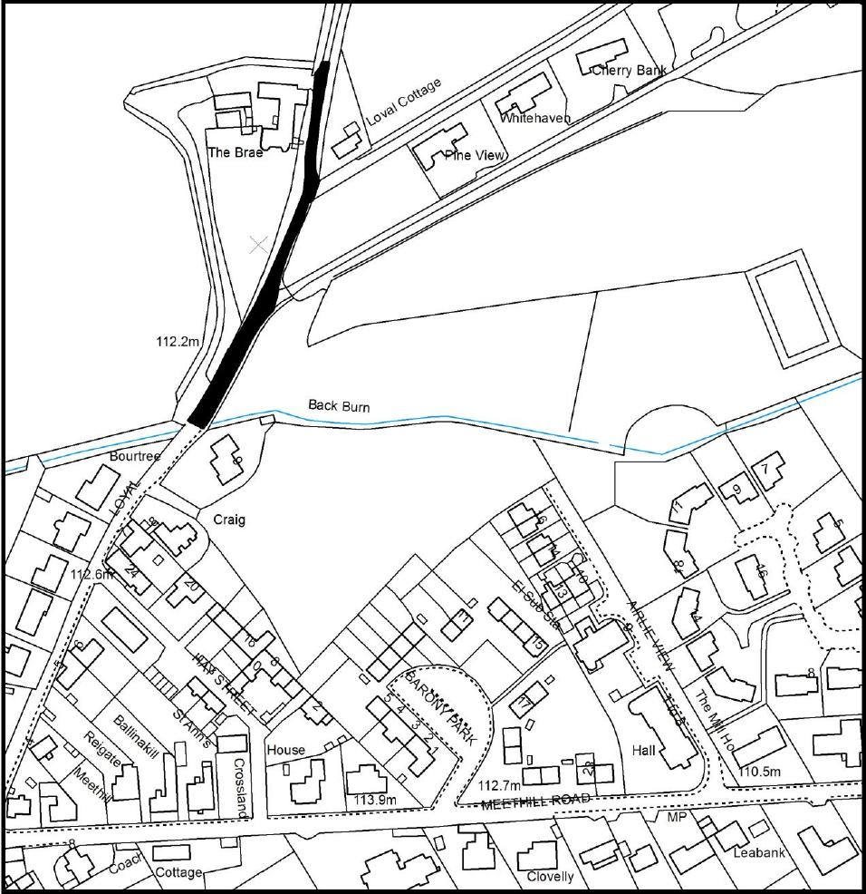
© Crown copyright [and database rights] 2017. OS 100016971. Use of this data is subject to terms and conditions.

