MORAY COUNCIL (ROAD CLOSURE, CHURCH LANE, HOPEMAN (BETWEEN THOM STREET AND FARQUHAR STREET) TEMPORARY ROAD CLOSURE) ORDER, 2024

The Moray Council in exercise of the powers conferred upon it by Section 14(1) of the Road Traffic Regulation Act 1984 (as amended) and of all other enabling powers hereby makes the following Order:

- This Order may be cited as “Moray Council (Church Lane, Hopeman (From Thom Street to Farquhar Street) Temporary Road Closure) Order 2024.

- The effect of this Order, which will come into operation from 29/04/2024 until 17/05/2024 will be to temporarily restrict traffic on Church Lane, Hopeman between Thom Street and Farquhar Street.

- The temporary restriction has been imposed for Scottish and Southern Electricity cabling works.

Given under the seal of Moray Council on 29 Februrary 2024

_________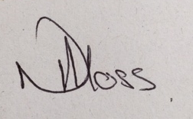_____________________
Head of Environmental and Commercial Services

