MORAY COUNCIL (B9103 LOSSIEMOUTH TO SHERIFFSTON ROAD (AT ARTHUR’S BRIDGE) TEMPORARY 7.5T WEIGHT LIMIT) EXTENSION ORDER (NO. 3) 2023

The Moray Council in exercise of the powers conferred upon it by Section 14(1) of the Road Traffic Regulation Act 1984 (as amended) and of all other enabling powers hereby makes the following Order:

- This Order may be cited as “Moray Council (B9103 Lossiemouth to Sheriffston Road (At Arthur’s Bridge) (Temporary 7.5T Weight Limit) Extension Order (No 3), 2023.

- The effect of this Order, which will come into operation on 04/10/2023 and continue until 04/04/2025 will be to temporarily impose a 7.5 tonne gross weight limit on Arthur’s Bridge.

- The temporary restriction has been imposed due to structure weakness on Arthur’s Bridge and is an extension to a previous order which came into effect from 04/04/2022 to 03/10/2023 and replaces the permanent 26T weight limit.

- In terms of the Act of 1984, as amended, the Council is satisfied that it has been necessary to impose this temporary Order as the bridge has been assessed for load carrying capacity and has been shown to be under strength.

- A signed diversion route will be available via B9103 Lossiemouth to Sheriffston Road >> A941 Lossiemouth to Elgin Road >> A96 Elgin to Fochabers Road >> B9103
.

Given under the seal of Moray Council on 5th September 2023

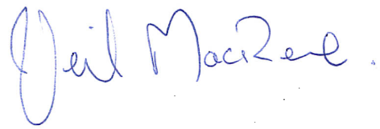
______________________________
p.p. Head of Environmental and Commercial Services

