MORAY COUNCIL (PROHIBITION OF WAITING, HIGH STREET, ELGIN (LOADING BAY IN FRONT OF FORMER JUNNERS STORE) TEMPORARY PROHIBITION OF WAITING) ORDER, 2023

The Moray Council in exercise of the powers conferred upon it by Section 14(1) of the Road Traffic Regulation Act 1984 (as amended) and of all other enabling powers hereby makes the following Order:

- This Order may be cited as “Moray Council (South Street, Elgin (Loading bay in front of former Junners store) Temporary Prohibition of Waiting) Order 2023.

- The effect of this Order, which will come into operation from 13/02/2023 until 28/04/2024 will be to temporarily restrict parking on South Street, Elgin at the loading bay in front of former Junners store.

- The temporary restriction has been imposed for pedestrian safety whilst works are ongoing at Gordon and McPhail building.

Given under the seal of Moray Council on 13 February 2023

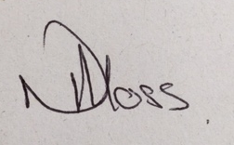
______________________________
Head of Environmental and Commercial Services

