MORAY COUNCIL (PROHIBITION OF WAITING, HIGH STREET, ELGIN (FROM NUMBER 27 TO NUMBER 54 AND SUSPENSION OF TAXI RANK BETWEEN MORAY COUNCIL HQ AND 34) TEMPORARY PROHIBITION OF WAITING) ORDER, 2023

The Moray Council in exercise of the powers conferred upon it by Section 14(1) of the Road Traffic Regulation Act 1984 (as amended) and of all other enabling powers hereby makes the following Order:

- This Order may be cited as “Moray Council (High Street, Elgin (From number 27 to number 54 and suspension of taxi rank between Moray Council HQ and 34) Temporary Prohibition of Waiting) Order 2023.

- The effect of this Order, which will come into operation from 30/01/2023 until 12/03/2023 will be to temporarily restrict parking on High Street, Elgin between number 27 and number 54 and suspension of taxi rankbetween Moray Council HQ and 34.

- The temporary restriction has been imposed to allow widening of existing footpath.

Given under the seal of Moray Council on 10 January 2023

_____________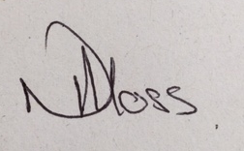_________________
Head of Environmental and Commercial Services

