MORAY COUNCIL (ROAD CLOSURE, NEWLANDS LANE, BUCKIE (BETWEEN HIGH STREET AND GARDEN LANE) TEMPORARY ROAD CLOSURE) ORDER, 2022

The Moray Council in exercise of the powers conferred upon it by Section 14(1) of the Road Traffic Regulation Act 1984 (as amended) and of all other enabling powers hereby makes the following Order:

- This Order may be cited as “Moray Council (Newlands Lane, Buckie (Between High Street and Garden Lane) Temporary Road Closure) Order 2022.

- The effect of this Order, which will come into operation from 30/01/2023 until 26/02/2023 will be to temporarily restrict traffic on Newlands Lane, Buckie between High Street and Garden Lane.

- The temporary restriction has been imposed to allow installation of new gas main.

Given under the seal of Moray Council on 21 December 2022
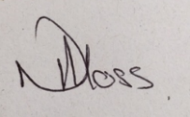

______________________________
Head of Environmental and Commercial Services

