MORAY COUNCIL (PROHIBITION OF WAITING, ST CATHERINES ROAD, FORRES (FROM LITTLE CROOK TO FIRE STATION) TEMPORARY PROHIBITION OF WAITING) ORDER, 2022

The Moray Council in exercise of the powers conferred upon it by Section 14(1) of the Road Traffic Regulation Act 1984 (as amended) and of all other enabling powers hereby makes the following Order:

- This Order may be cited as “Moray Council (St Catherines Road, Forres (From Little Crook to Fire Station) Temporary Prohibition of Waiting) Order 2022.

- The effect of this Order, which will come into operation from 27/06/2022 until 19/08/2022 will be to temporarily restrict parking on St Catherines Road, Forres between Little Crook and Fire Station.

- The temporary restriction has been imposed to allow installation of new pedestrian crossing traffic lights.

Given under the seal of Moray Council on 01 June 2022

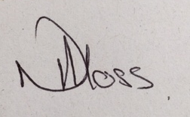
______________________________
Acting Head of Environmental and Commercial Services

