ROAD TRAFFIC REGULATION ACT 1984: SECTION 14
East Lothian Council hereby give notice under Section 14(2) of the Road Traffic Regulation Act 1984, as amended, that for the reason set out in Section 14(1)a of that act the following restrictions will be introduced:
B6414 CROSSGATEHALL TO ELPHINSTONE
TTRO 069a/20/JB
ROAD CLOSURE AND PARKING SUSPENSION
REASON | EXTENT | DURATION
 |  | FROM | TO
TO FACILITATE CARRIAGEWAYREPAIR WORKS | B6414 FROM CROSSGATEHALL BRIDGE EASTWARDS TO ELPHINSTONE TOWER FARM COTTAGES, A DISTANCE OF 2492m OR THERE BY | TUESDAY  21st JULY 2020 | FRIDAY  31st JULY 2020

PEDESTRIAN ACCESS WILL BE MAINTAINED.
EMERGENCY ACCESS SHALL BE MAINTAINED.
THIS NOTICE HAS A MAXIMUM DURATION OF 1 PERIOD OF 4 DAYS AND 1 PERIOD OF 5 DAYS.
VEHICLES ASSOCIATED WITH THE WORKS SHALL BE EXEMPT FROM THE RESTRICTIONS.
NO RESTRICTIONS WILL BE IN PLACE ON SATURDAY OR SUNDAY.
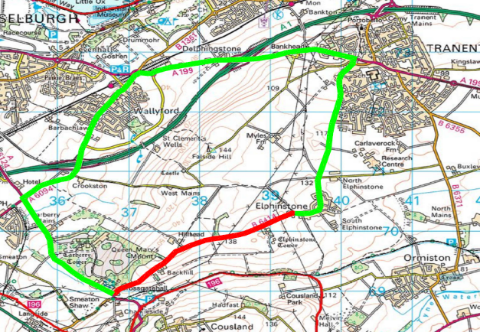

Area of Road Closure
Diversion Route
PP 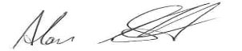
CALLUM REDPATH
TEAM MANAGER – ENGINEERING, ROAD SERVICES

