ROAD TRAFFIC REGULATION ACT 1984: SECTION 14
East Lothian Council hereby give notice under Section 14(2) of the Road Traffic Regulation Act 1984, as amended, that for the reason set out in Section 14(1)a of that act the following restrictions will be introduced:
LAMER STREET, DUNBAR
TTRO 163/20/KH
ROAD CLOSURE
REASON | EXTENT | DURATION
 |  | FROM | TO
TO FACILITATE DUNBAR EAST BEACH SEA DEFENCE PROJECT | ON LAMER STREET FROM WOODBUSH TO STABLE COURT – ACCESS TO BOTH WOODBUSH AND STABLE COURT TO BE MAINTAINED | Tuesday  28th July 2020 | Wednesday 30th September 2020

EMERGENCY ACCESS SHALL BE MAINTAINED.
VEHICLES ASSOCIATED WITH THE WORKS SHALL BE EXEMPT FROM THE RESTRICTIONS.

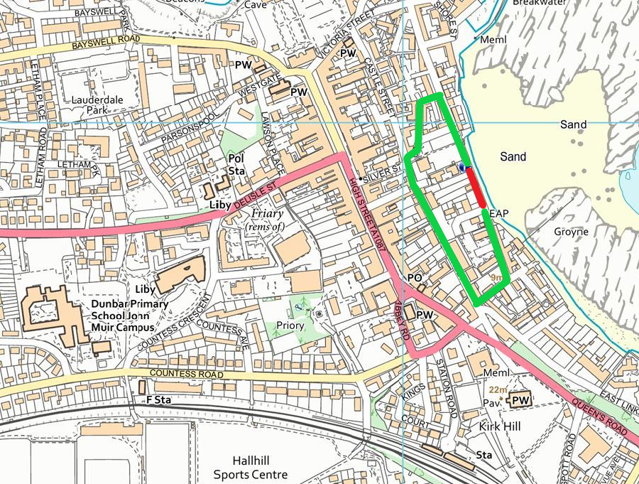

Diversion Route
Road Closure

TWR 6.7.2020

Tom Reid

