ROAD TRAFFIC REGULATION ACT 1984: SECTION 14

East Lothian Council hereby give notice under Section 14(2) of the Road Traffic Regulation Act 1984, as amended, that for the reason set out in Section 14(1)a of that act the following restrictions will be introduced:
VICTORIA STREET & LAMER STREET, DUNBAR
TTRO 119/20/KH

NO WAITING, LOADING AND UNLOADING
REASON | EXTENT | DURATION
 |  | FROM | TO
TO FACILITATE DUNBAR EAST BEACH SEA DEFENCE PROJECT | Parking Suspension on Victoria Street on both sides for approximately 30m West of Lamer Street. Parking Suspension on Lamer Street on both sides for approximately 25m South of Victoria Street. | Monday 1st June 2020 | Monday 27th July 2020

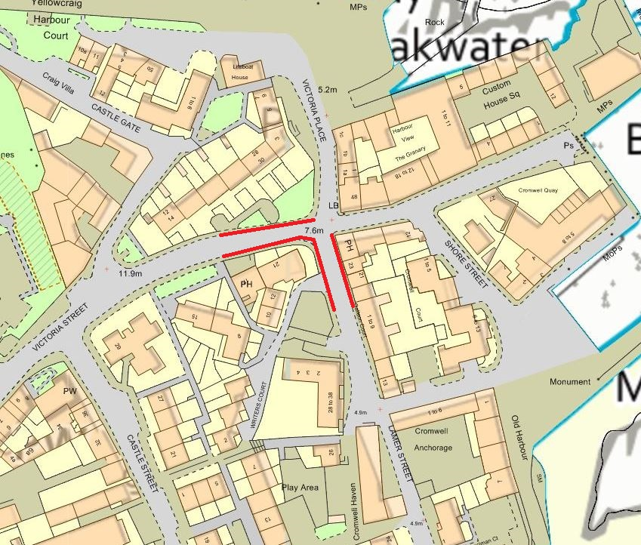

Extent of Restriction

TWR 12/5/20

Tom Reid
Head of Infrastructure

