ROAD TRAFFIC REGULATION ACT 1984: SECTION 14

East Lothian Council hereby give notice under Section 14(2) of the Road Traffic Regulation Act 1984, as amended, that for the reason set out in Section 14(1)a of that act the following restrictions will be introduced.

THE WYND GIFFORD
TTRO Ref No.383/19/AR

Road Closure
REASON | EXTENT | DURATION
 |  | FROM | TO
CABLING OPPERATIONS | FROM THE JUNCTION OF B6355 TO THE JUNCTION OF PARK ROAD FOR A DISTANCE OF 40M | Monday, 21 October 2019 | Friday, 25 October 2019
 |  | 07.30 am | 16.30 pm
- Pedestrian and emergency access to be maintained.
- This notice has a maximum duration of 5 days.
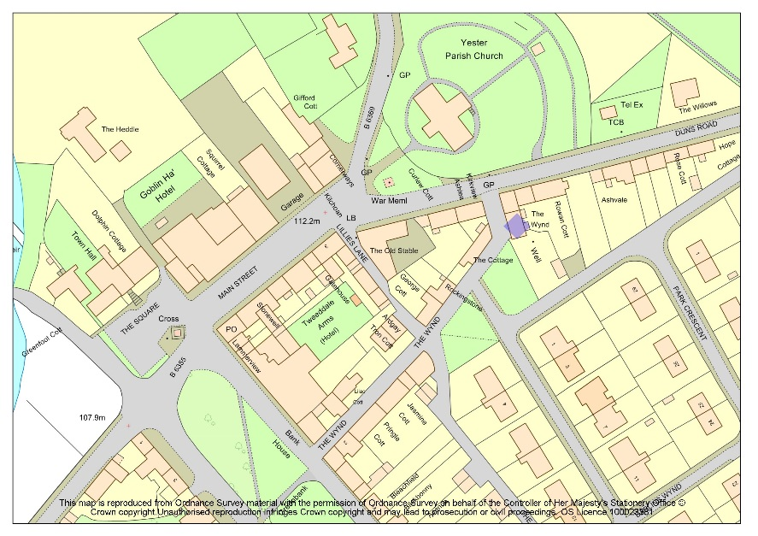

EXTENT OF ROAD CLOSURE

DIVERSION ROUTE
CALLUM REDPATH
TEAM MANAGER-ENGINEERING
ROAD SERVICES

