EAST LOTHIAN COUNCIL
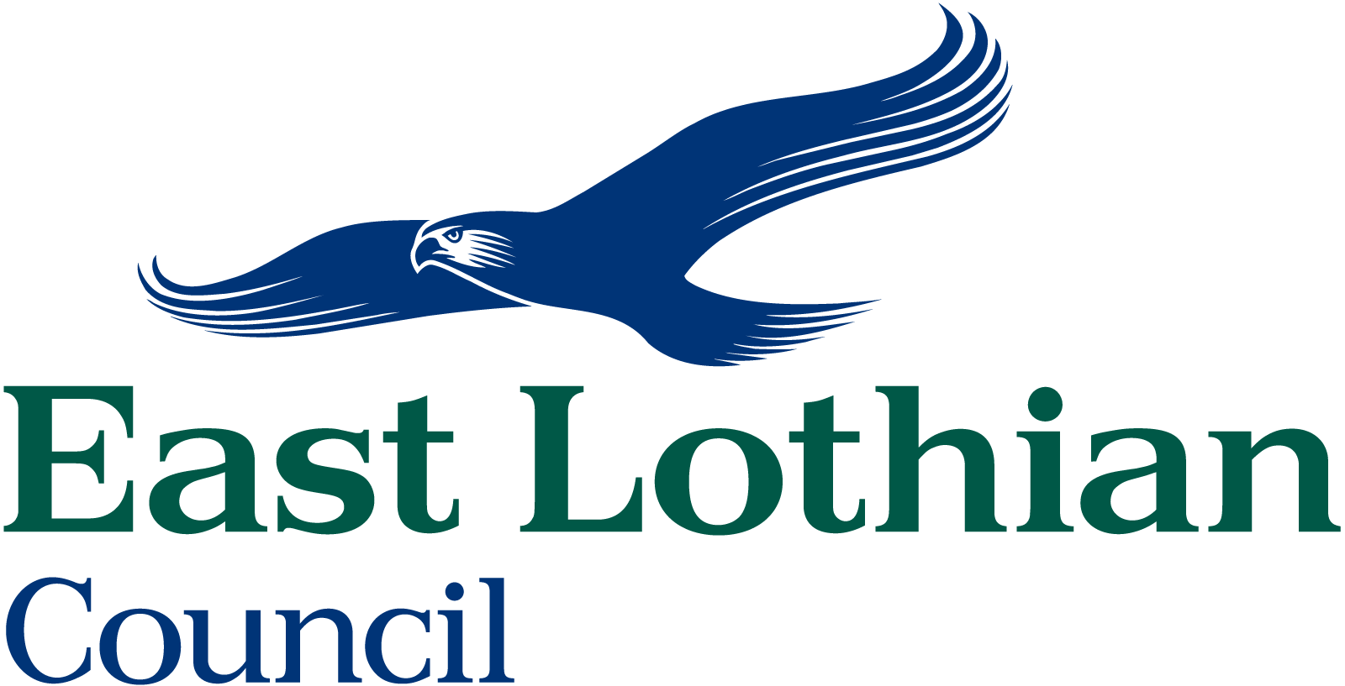
TRANSPORTATION DIVISION
ROAD NETWORK MANAGEMENT
BEST VALUE BENCHMARKING
QUESTIONNAIRE FOR WORK AT: C76 SOUTHFIELD CULVERT

As part of East Lothian Councils commitment to Best Value and continuous improvement, this questionnaire has been created to obtain your views on the standards of the recently completed works carried out near you.

I would be obliged if you would indicate your views by placing a in the appropriate box and return the completed form in the stamp addressed envelope provided.

How satisfied were you with the following aspects of the work | Very Satisfied | Satisfied | Dissatisfied | Very Dissatisfied
- The notification of the project (start /finish dates)?
- Access arrangements during the work?
- The type of materials used?
- Traffic signing/barriers i.e. site safety?
- Duration of the works?
- Performance of the workforce?
- Attitude of Workforce and Staff?
- The overall standard of completed works?
- The works have enhanced your area?

Any Other Comments (Including Reasons for Any Dissatisfaction):

It would be helpful if you supplied your name and address below however this is not compulsory and if you do not provide this information your views will still be taken into account

Name (BLOCK CAPITALS)

Address

Signature Date

