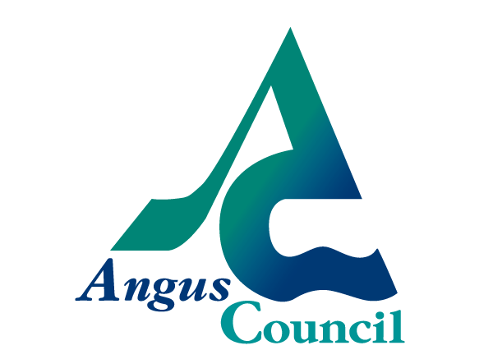
PUBLIC NOTICE

THE COMMUNITY EMPOWERMENT (SCOTLAND) ACT 2015
NOTICE OF CONSULTATION ON DISPOSAL OR CHANGE OF USE OF COMMON GOOD PROPERTY

Angus Council has received a Community Asset Transfer request and because of this will be considering changing the use of property held as part of the Forfar Common Good. Before taking a decision it requires to consult under Section 104 of the Community Empowerment (Scotland) Act 2015.

Community Asset Transfer request:
A community asset transfer request has been made by Strathmore Rugby Football Club and relates to the rugby pitch at Inchmacoble, by Forfar Loch
The request is for purchase of the smaller (west) rugby pitch
The proposal is to continue to use the pitch for rugby training and to have the option to develop the land in the future for sporting use.
The likely timescales proposed for the application include submission to Angus Council Policy and Resources Committee by 18th September 2019.
The documents relating to this request can be viewed online at https://www.tellmescotland.gov.uk/notices/angus/
Anyone may make representations about this request to Angus Council. Representations must be in writing and include the name and address of the person making it. All representations will be published.
Representations must be made by 27th May 2019.They should be sent to CommAssetTransfer@angus.gov.uk

