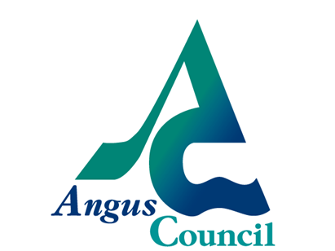 PUBLIC NOTICE
ASSET TRANSFER UNDER THE COMMUNITY EMPOWERMENT ACT
NOTICE OF ASSET TRANSFER REQUEST

An asset transfer request has been made to Angus Council under Part 5 of the Community Empowerment (Scotland) Act 2015.
The request has been made by IMPS (Inch Maintenance and Preservation Society) and relates to the land/building known currently as former Brechin Leisure Centre, Inch park, River Street, Brechin, Angus, DD9 7HQ (site 359982)
The request is for lease of the former Brechin Leisure Centre, Inch park, River Street, Brechin, Angus, DD9 7HQ (site 359982)
The proposed use of the land/building is to provide a community resource hub for the people of Brechin particularly those living in East Brechin. The applicant believes the hub will serve to meet the needs of all the community – from young to old and be truly intergenerational, creating a vibrant, welcoming and inspiring focal point for residents and others.

The documents relating to this request can be viewed online at https://www.tellmescotland.gov.uk/notices/angus/
Anyone may make representations about this request to Angus Council. Representations must be in writing and include the name and address of the person making it.
All representations will be published.

Representations must be made by 27th May 2019. They should be sent to CommAssetTransfer@angus.gov.uk General Information about the asset transfer scheme is available at [www.gov.scot/asset transfer].

